Concept of Operations

Project Grover: The Geoglyph Rover

Wednesday, 7 August 2024

Version 1

|  |  |
| --- | --- |
| Abhishek Chozhiyattil |  |
| Adnan Azmie |  |
| Russell Rehim |  |
| Vikalp Shendekar |  |
| Viswadeep Kopalli |  |

# Project Timeline

|  |  |  |
| --- | --- | --- |
| **Milestone** | **Date** | **Description** |
| Project Kick-off | 26/07/2024 | Initial team meeting and project planning |
| Design Completion | 09/08/2024 | Finalize system design |
| Integration Phase | DD/MM/YYYY | Integrate hardware and software components |
| Testing Phase | DD/MM/YYYY | Conduct system testing and validation |
| Final Deployment | DD/MM/YYYY | Full system deployment and demonstration |
| Project Completion | DD/MM/YYYY | Submit final report and deliverables |

# Purpose of Document

This document serves as the Concept of Operations (ConOps) for Project Grover, an innovative initiative aimed at developing a large-scale outdoor drawing robot. The purpose of this document is to provide a comprehensive overview of the project, detailing its objectives, scope, and operational framework. It outlines the technical and strategic approach that will be employed by Team Project Grover to achieve the project’s goals. The document is intended to guide all stakeholders, including students, faculty advisors, clients, and potential collaborators, through the planned phases of development, integration, and implementation of Project Grover. It aims to ensure a clear understanding of the project's vision, methodologies, and expected outcomes.

The contents of this document include a detailed description of Project Grover’s objectives, the background and rationale for the project, the operational environment, system requirements, and the roles and responsibilities of team members. Additionally, it covers the project's timeline, key milestones, and evaluation criteria for success. The intention is to facilitate effective communication and coordination among all parties involved, fostering a collaborative environment that supports the innovative development of the outdoor drawing robot. This document is crucial for aligning the efforts of the team and ensuring that all aspects of the project are executed smoothly and efficiently.

# Scope of the Project

## Overview

Project Grover is an ambitious initiative aimed at developing a large-scale outdoor drawing robot capable of autonomously executing specified tasks. Leveraging advanced technologies such as GPS, Lidar, Sonar, 3D cameras, and long-range radio systems, the project builds on foundational work from Tech-Launcher and utilizes open-source software to create a robust mechanical drawing system. Initially integrated with a RC vehicle for simulation purposes, the project will transition these autonomous capabilities to a commercial line marking machine. The team will focus on the development, integration, and debugging of both hardware and software systems to ensure precise and accurate operation in various outdoor environments. Key aspects include conducting autonomous simulations, utilizing advanced technologies to enhance performance, collaborating closely with the Project Host (ANU College of Arts) to meet specific drawing requirements, and performing thorough testing and validation in designated ANU Ovals. Comprehensive documentation of progress, challenges, and outcomes will be maintained, with final deliverables presented to stakeholders. Ultimately, Project Grover aims to deliver a fully autonomous line drawing machine capable of performing specific tasks with high precision, demonstrating the practical application of advanced robotic technologies.

# Project Boundaries

## In Scope:

RC Vehicle as a Prototype:

* Using the RC vehicle to kickstart the project and perform autonomous simulation.
* Ensuring the RC vehicle accurately simulates the final autonomous behaviour of the line drawing machine.

Integration to Line Drawing Machine:

* Transitioning the tested and validated autonomous capabilities from the RC vehicle to the actual line drawing machine.
* Ensuring the line drawing machine can autonomously execute specified drawing tasks.

Autonomous Operation in Specified Locations:

* Final goal is for the line drawing machine to autonomously perform specific drawing tasks in any of the ANU Ovals provided by the project team.

Ongoing Collaboration and Testing

* Client Interaction: Continue collaboration with clients to refine drawing requirements and ensure the final product meets expectations.
* Comprehensive Testing: Perform rigorous testing and validation of the autonomous line drawing machine in various outdoor settings.

Comprehensive Documentation

* Project Reports: Detailed documentation of each phase, including development, integration, testing, and client feedback.
* Final Presentation: Presentation of the overall project outcomes, highlighting the transition from RC vehicle simulation to a fully autonomous line drawing machine.

Out of Scope:

* New RC Vehicle Prototypes: Development of additional RC vehicle prototypes beyond the initial scale model.
* Advanced AI Algorithms: Creating sophisticated AI for complex drawing tasks beyond basic line following.
* Commercialization Strategies: Formulating strategies for commercializing the line drawing technology.
* Environmental Impact Studies: Conducting extensive studies on the environmental impact of the robot.
* Terrain Adaptation: Making the line drawing machine work on uneven terrains, including integrating suspension systems.
* Extended Range: Enabling the line drawing machine to operate across the entire ANU Campus or within a 1km radius.

# Goals and Objectives

## Goals:

Develop an Autonomous Line Drawing Machine: Create a machine capable of executing specific drawing tasks autonomously in designated outdoor areas.

## Objectives:

1. RC Vehicle Integration: Develop and integrate mechanical drawing systems onto an RC vehicle for initial autonomous simulation.
2. Simulation Transition: Successfully transfer autonomous systems from the RC vehicle to the line drawing machine.
3. Technology Utilization: Integrate GPS, Lidar, Sonar, 3D cameras, and long-range radio systems to enhance operational capabilities.
4. Client Collaboration: Understand and implement specific drawing requirements through close collaboration with clients.
5. Testing and Validation: Conduct thorough testing and validation in outdoor settings, specifically in ANU Ovals.
6. Documentation: Provide detailed documentation and presentations of project progress and outcomes.

# Scope Management Plan

To ensure the project's scope is maintained and managed effectively, the following control measures and processes will be implemented:

## Control Measures:

* Regular Project Meetings: Conduct regular meetings with stakeholders through Microsoft Teams and in-person at ANU College of Arts to review progress and discuss any potential scope changes.
* Detailed Documentation: Maintain comprehensive documentation of project requirements and specifications to serve as a reference for scope verification.
* Change Control Process: Implement a structured change control process to evaluate and approve any proposed changes to the project scope.

## Utilization of Resources:

* Workshop and Storage: Allocate specified workshop and storage space at Birch Building for working on the RC vehicle and line drawing machine.
* Engineering Building: Use the Engineering Building for working on SolidWorks to develop CAD models for the line drawing machine.
* GitHub Repository: Employ GitHub for project repository management and document storage.
* Team Meetings: Arrange in-person project member meetings at Toad Hall, ANU, for discussions without the host group.

## Change Control Process:

* Identification: Any team member or stakeholder can propose a change to the project scope.
* Evaluation: The proposed change is reviewed by the project team and stakeholders to assess its impact on the project's goals, timeline, and resources.
* Approval: If the change is deemed beneficial and feasible, it is approved by the project manager and relevant stakeholders.
* Implementation: The approved change is integrated into the project plan, with necessary adjustments made to the timeline and resources.
* Documentation: All changes are documented and communicated to all team members and stakeholders to ensure transparency and alignment.

## Additional Measures:

* Collaborative Tools: Utilize Microsoft Teams for virtual collaboration and communication, ensuring efficient coordination among team members.
* In-Person Collaboration: Facilitate hands-on work and collaboration at designated locations, such as Birch Building and Toad Hall, to enhance productivity and project cohesion.
* Continuous Learning and Improvement: Use the project as a learning platform to refine automation techniques and iterate on improvements to the line drawing equipment's operational efficiency.

By adhering to this enhanced scope management plan, the Capstone team will maintain a clear and focused project trajectory, ensuring that Project Grover achieves its intended outcomes efficiently and effectively. The integration of structured control measures, robust change management, and strategic utilization of resources will support the team's efforts in automating the line drawing machine and achieving project success.

# Referenced Documents

## Project Management Plan:

* Function Flow Block Diagram (FFBD):
* Timelines Table:

|  |  |  |
| --- | --- | --- |
| Milestone | Deadline | Deliverable |
| Project Kick-off | 29/07/2024 | Initial meeting and scope definition |
| Design Phase | 08/08/2024 | Completed CAD models |
| Simulation Completion |  | RC vehicle autonomous simulation |
| Integration Phase |  | Line drawing machine integration |
| Testing Phase |  | Outdoor testing in ANU Ovals |
| Final Presentation |  | Project outcomes presentation |
|  |  |  |

* Risk Assessments:

|  |  |  |
| --- | --- | --- |
| Risk | Impact | Mitigation Strategy |
| Component Delays | High | Early procurement, alternative suppliers |
| Technical Failures | Medium | Regular testing, robust design |
| Scope Creep | Medium | Strict change control process |
| Environmental Factors | Low | Contingency planning for outdoor testing |

1. Meeting Minutes:
   * Detailed documentation of each meeting with the host, capturing key points, decisions made, and action items. These minutes serve as a historical record and help in tracking progress and accountability.
2. GitHub Repository:
   * The repository is organized with folders for code, CAD models, documentation, and meeting minutes. Each commit is documented with clear messages to ensure traceability and collaboration efficiency.
3. Extra Motors and Batteries:
   * Requirement: Additional motors and batteries are necessary to ensure the line drawing machine operates efficiently.
   * Cost Sanction: Budget allocation and approval for purchasing the required motors and batteries.
   * Availability Delays: Acknowledgment of potential delays in the procurement and delivery of these components, which could impact the project timeline.

# Team Structure

## Team A (Data Acquisition)

* Vishwadeep Kopalli
* Adnan Azmie
  + Responsibilities: Data acquisition, documentation, and communication with the host, ANU staff, and shadow team.

## Team B (Design & Manufacturing)

* Abhishek Chozhiyattil
* Russell Rehim
* Vikalp Shendekar
  + Responsibilities: Design and manufacturing, documentation, and communication with the host, ANU staff, and shadow team.

## Responsibilities and Authorities

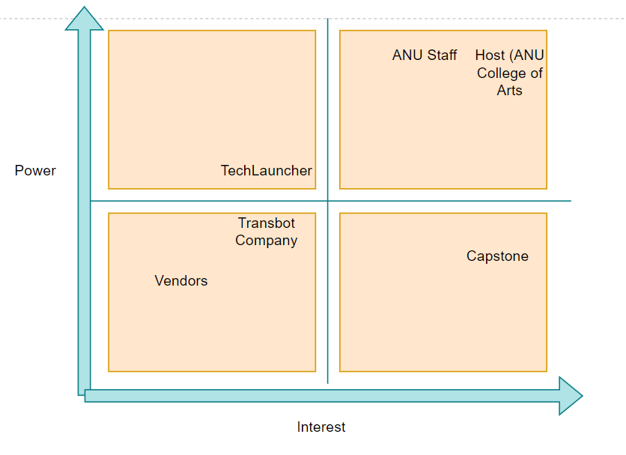

Figure 1 Power vs Interest Graph

## Key Stakeholders and Their Roles

### Tec Launcher

* Role: Oversight, resources, mentorship
* Responsibility: Align project with educational goals, provide support, evaluate progress

### Capstone Team (Team Grover & Shadow Team)

* Role: Execute project
* Responsibility: Develop and deliver the autonomous line drawing machine, manage tasks, coordinate stakeholders

### ANU Teaching Team

* Role: Academic support, evaluation
* Responsibility: Offer technical advice, monitor progress, assess academic merit

### Project Host (ANU College of Arts)

* Role: Primary client
* Responsibility: Define scope, provide resources, validate deliverable

### Graco Line Marking Machine Company

* Role: Technology and expertise provider
* Responsibility: Supply components, ensure system compatibility

### Transbot RC Vehicle Company

* Role: RC vehicle supplier
* Responsibility: Provide RC vehicles and technical support

### Vendors

* Role: Component suppliers
* Responsibility: Ensure timely delivery of parts, provide specifications

# Stakeholder Management Plan

## 1. Identification of Stakeholders:

* Primary Stakeholders: Tech-Launcher, Capstone Team, ANU Teaching Team, Project Host (ANU College of Arts)
* Secondary Stakeholders: Grace Line Marking Machine Company, Transbot RC Vehicle Company, Vendors

## 2. Communication Plan:

Regular Meetings:

* Weekly Team Meetings: Capstone Team
* Bi-weekly Stakeholder Meetings: Primary stakeholders
* Tools: Microsoft Teams, Email, GitHub, In-person Meetings

3. Engagement Strategies:

* Tech-Launcher: Regular updates, key decision involvement
* Capstone Team: Daily stand-ups, internal communication
* ANU Teaching Team: Periodic updates, academic advice
* Project Host: Frequent consultations, requirement validations
* Grace Line Marking Machine Company: Technical support
* Transbot RC Vehicle Company: Technical support
* Vendors: Clear specifications, timely orders

4. Feedback and Adaptation:

* Feedback Mechanisms: Surveys, feedback sessions, issue tracking
* Adaptation: Change control process, continuous improvement

5. Documentation and Reporting:

* Meeting Minutes: Document all meetings
* Progress Reports: Highlight achievements, issues, next steps
* Final Report and Presentation: Comprehensive project outcomes

6. Risk Management:

* Identify Risks: Regular assessment
* Mitigation Strategies: Multiple communication channels, stakeholder engagement strategies

This plan ensures effective communication, engagement, and collaboration with all stakeholders, contributing to the project's success.